

CSBG Performance Management Website
  - Exercise Guide 02

Contents
ICON KEY ii
Purpose iii
Using this Exercise Guide iii
Scenario 1 1
Exercise 1 1
Scenario 1 Solution 2
Scenario 1 Result 4
Scenario 2 5
Exercise 2 5
Scenario 2 Solution 6
Scenario 2 Result 9
Scenario 3 10
Exercise 3 10
Scenario 3 Solution 11
Scenario 3 Result 14

ICON KEY
Throughout this guide, you’ll notice a few icons. This page briefly explains the significance of the icons.

Swimming Icons

The swimming icons are in each report created within this guide to represent a level of expertise in creating reports.

Puzzle Icon
The puzzle icon represents the ability to jump to other sections within this guide by clicking the linked text right below it.

Purpose
The purpose of this Exercise Guide is to show how to use the Community Services Block Grant (CSBG) Performance Management website to generate different reports, which will assist CSBG lead agencies in navigating and learning the features of the website.

The scenarios are examples of how you may use the Data Warehouse to produce graphics or access data that you reported about CSBG. Each scenario is accompanied by a question to answer using the report that you produce.

Please note these are steppingstones to developing expertise in using the website. Overtime, the aim is developing the ability to use the website to answer different stakeholder questions from the unique perspective of each state, territory, and CSBG eligible entity.

Using this Exercise Guide
- Review the scenario, which includes a question from a CSBG stakeholder and how the CSBG State Administrator chooses to respond.
- Attempt the exercise to create the report.
- Answer the question using the report that you created.
- Review the solution steps for each scenario.
- Compare your report to the final result.

Scenario 1
Imagine that you are a state administrator for CSBG in Wisconsin. You are preparing for a statewide meeting with Wisconsin’s eligible entities and plan to present data on organizational standards and agency capacity building in Fiscal Year (FY) 2021. Consider how the Data Warehouse can help you prepare for this meeting.

Wade In

You decide to present a graph showing Wisconsin’s progress toward meeting organizational standards in FY21. Using CSBG Quick Facts in the Data Warehouse, how would you generate this report?

In addition to demonstrating progress toward meeting organizational standards, you choose to discuss CSBG spending on agency capacity building with the CSBG eligible entities in Wisconsin. Using Advanced Data & Analytics in the Data Warehouse, how would you generate a report on the amount of CSBG funds that each eligible entity spent on agency capacity building in FY21?

Exercise 1

How can you use the report that you generated in Advanced Data & Analytics to answer the following question:

Question #1: How many CSBG eligible entities in Wisconsin spent CSBG funds on agency capacity building in FY21?

Scenario 1 Solution
Scenario 1 Result
Scenario 2

Scenario 1 Solution

STEP 1: Once in the Data Warehouse, select the CSBG Quick Facts option.

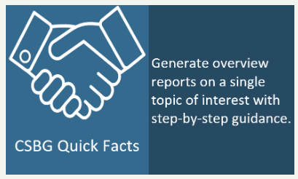

STEP 2: In the CSBG Quick Facts screen, select Single State Reports (since we are only interested in looking at one state).

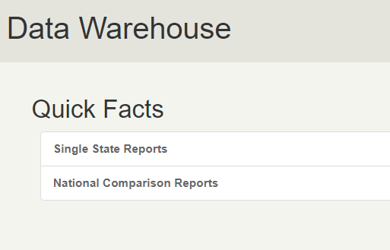

STEP 3: In the Single State Reports screen, select “What percentage of CSBG eligible entities are meeting Organizational Standards?”

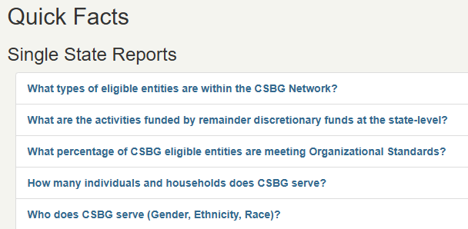

STEP 4: On the State Selection screen, select Wisconsin. Then, select Next.

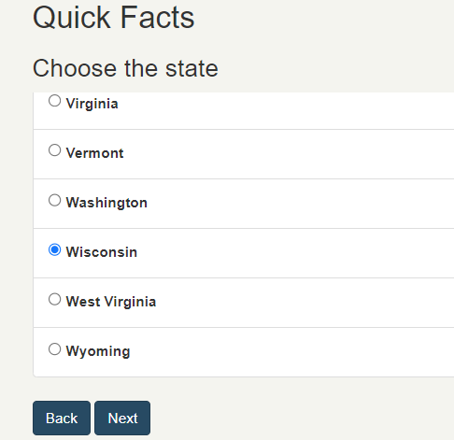

STEP 5: On the Year Selection screen, select “2021.” Then, select Next.

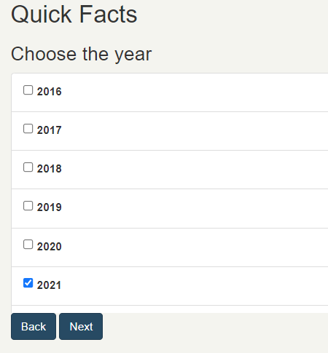

Scenario 1 Result

Using this bar graph, we can answer Question #1: The actual percentage of entities meeting 100% of organizational standards in FY21 was 72.22%.

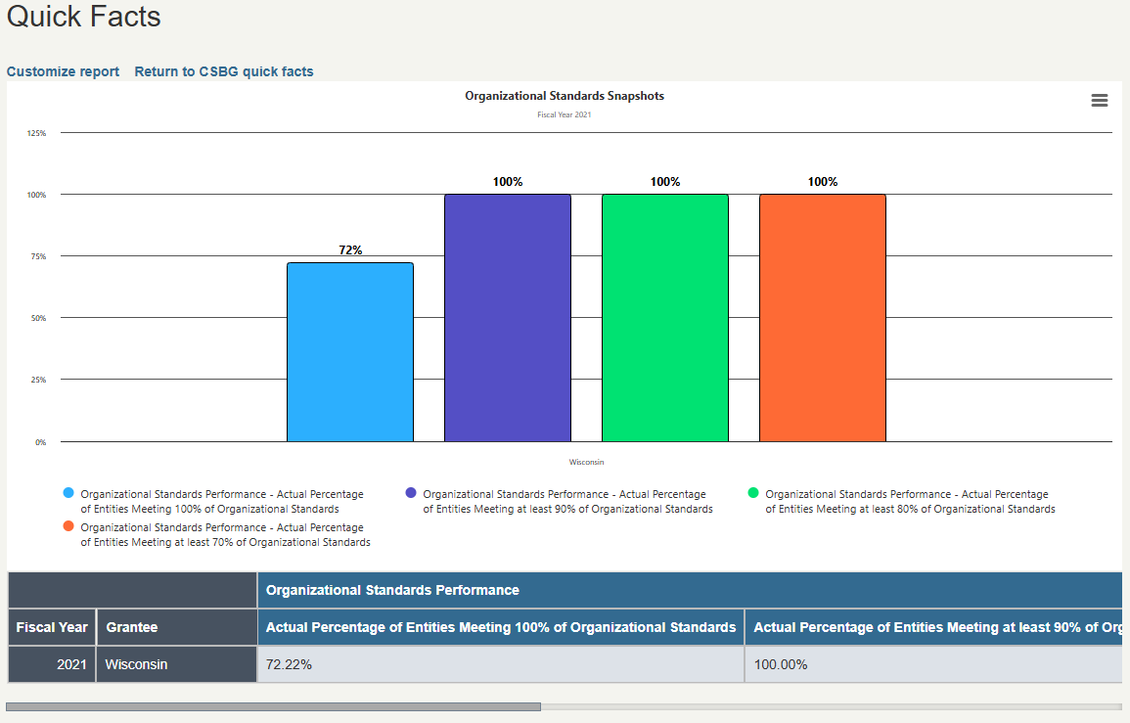

Scenario 1

Scenario 2

Jump In

In addition to demonstrating progress toward meeting organizational standards, you choose to discuss CSBG spending on agency capacity building with the CSBG eligible entities in Wisconsin. Using Advanced Data & Analytics in the Data Warehouse, how would you generate a report on the amount of CSBG funds that each eligible entity spent on agency capacity building in FY21?

Exercise 2

How can you use the report that you generated in Advanced Data & Analytics to answer the following question:

Question #2: How many CSBG eligible entities in Wisconsin spent CSBG funds on agency capacity building in FY21?

Scenario 2 Solution
Scenario 2 Result
Scenario 1
Scenario 3

Scenario 2 Solution

STEP 1: Once in the Data Warehouse, select the Advanced Data & Analytics option.

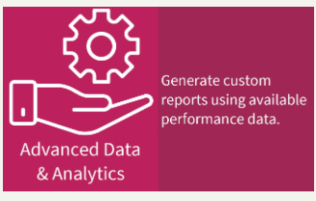

STEP 2: Under Step 1, select your years of interest as well as the geographic level of data you are interested in. For this example, select “2021,” “Local Data (Eligible Entity),” and Wisconsin.

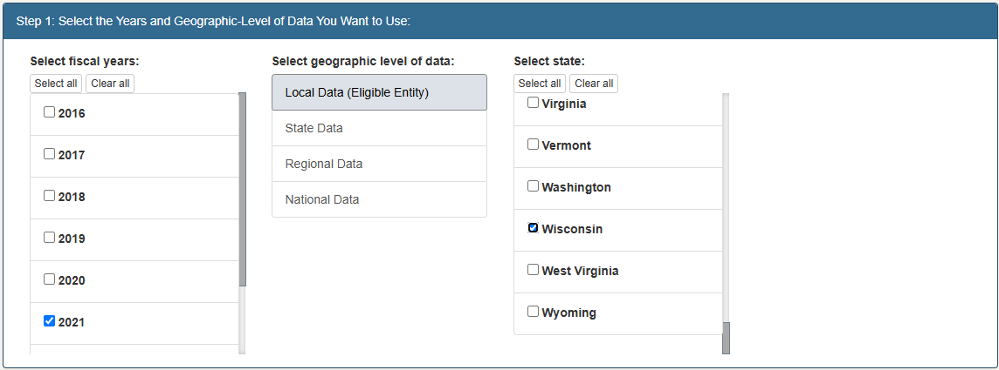

STEP 3: Under Step 2, select the topic area “Eligible Entity Expenditures, Capacity, and Resources (Module 2)- Eligible Entity.” Then, select the sub-topic “Expenditures” and the data field “CSBG Expenditure Domains (By Entity).”

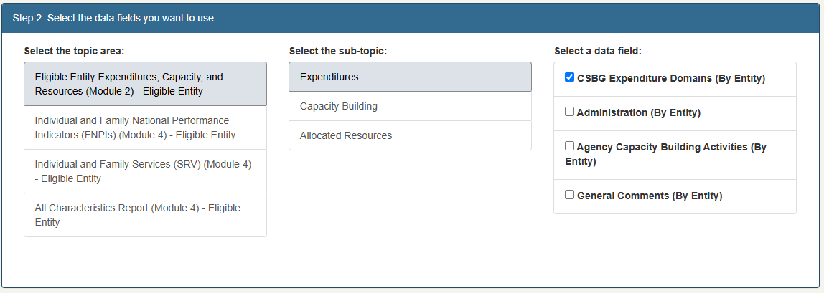

STEP 4: Under Step 3, you can add optional filters. Here, we will unselect all columns except for “Agency Capacity Building.”

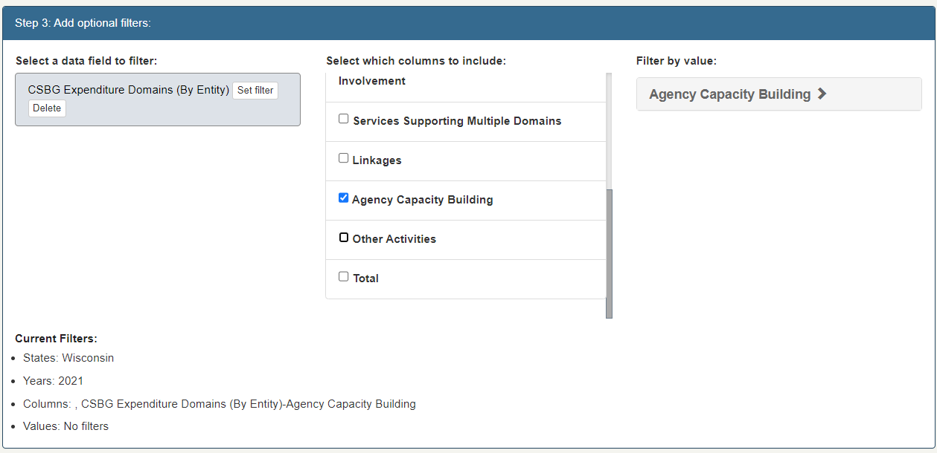

STEP 5: Under Step 4, we have options on how to display our data. For this report, we will select “Bar graph.” We have the option to name our report, then we can generate it using the Create Data Report button.

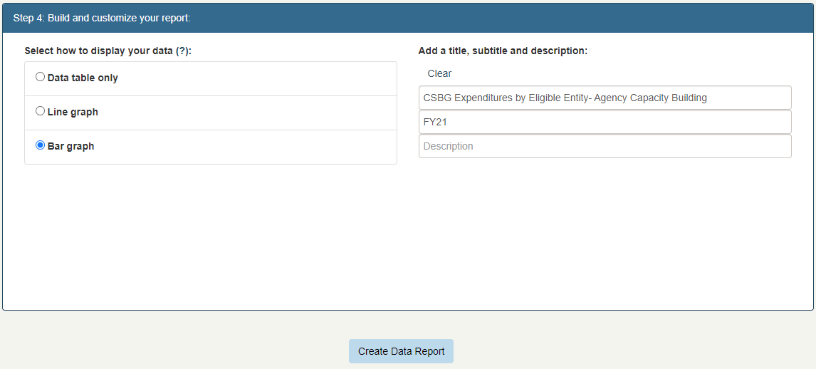

Scenario 2 Result

Using the bar graph we generated, we can answer Question #2: The number of eligible entities that spent CSBG funds on agency capacity building in FY21 was 15.

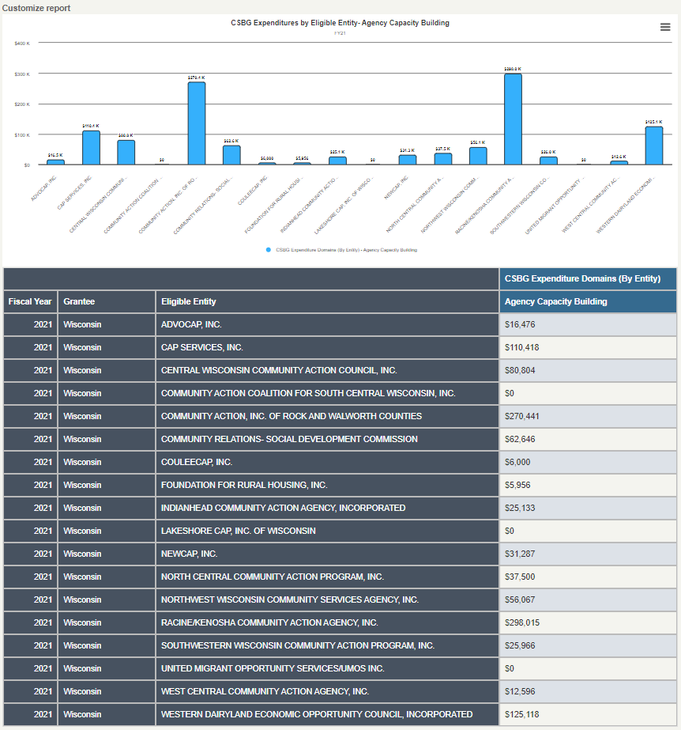

Scenario 2

Scenario 3

Deeper Dive

You decide to compare the share of CSBG funds that entities spent on agency capacity building activities to the total amount of CSBG funds spent by each entity. Using the Customize option at the top of the report screen, how would you add total CSBG expenditures to your report?

Exercise 3

How can you use the report you generated using the Customize option to answer the following question:

Question #3: Which CSBG eligible entity in Wisconsin spent the highest share of their total CSBG expenditures on agency capacity building?

Scenario 3 Solution
Scenario 3 Result
Scenario 2

Scenario 3 Solution

STEP 1: Starting on the results page from the previous example, click “Customize report” at the top of the page.

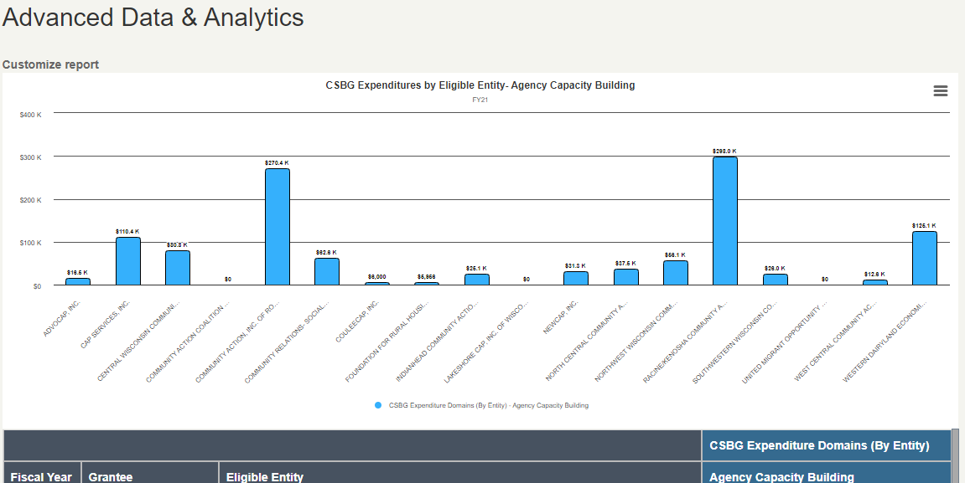

STEP 2: Under Step 1 of the customize screen, some criteria will already be selected from our previous report—including the year (2021), the geography (Local Data (Eligible Entity)), and Wisconsin (so we don’t need to add anything here).

Step 3: Under Step 2 of the customize screen, “Eligible Entity Expenditures, Capacity, and Resources (Module 2)- Eligible Entity,” “Expenditures,” and “CSBG Expenditure Domains (By Entity)” will already be selected (so we don’t need to add anything here).

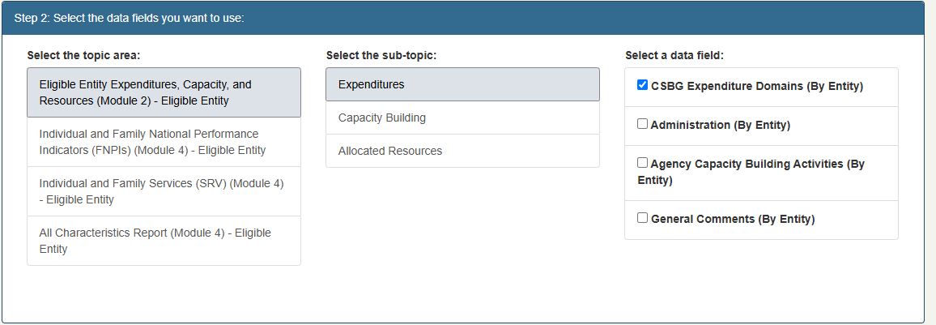

Step 4: Under Step 3 of the customize screen, “Agency Capacity Building” will already be selected. In addition to this, we want to select “Total.”

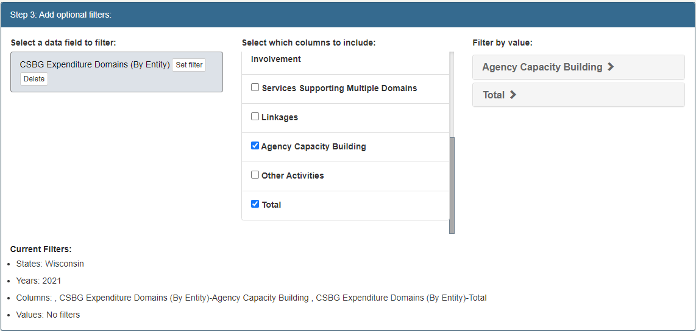

Step 4: Under Step 4, we will select “Bar graph” to compare spending on expenditures with total spending. Under “Add a title, subtitle, and description,” you may choose to update the title of your report. Once that is complete, we’ll click “Create Data Report.”

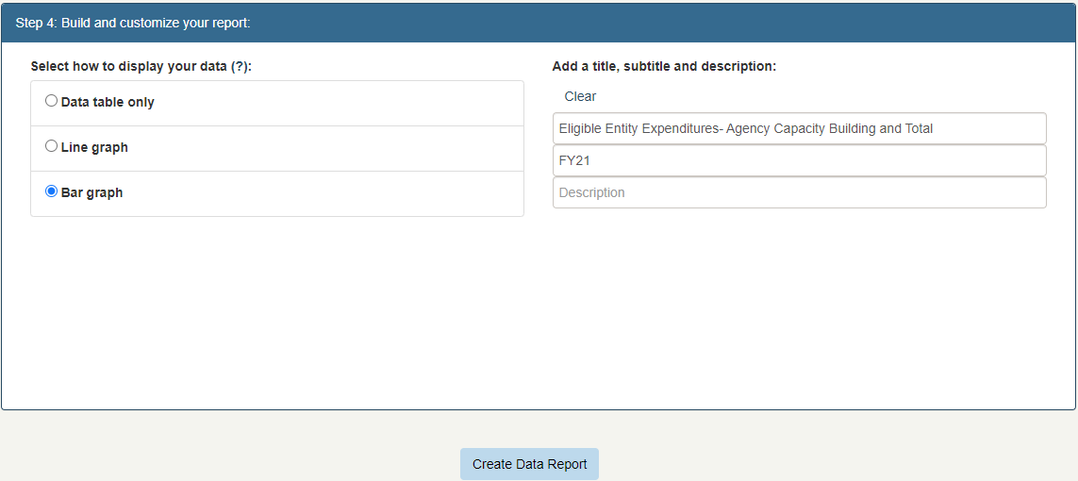

Scenario 3 Result

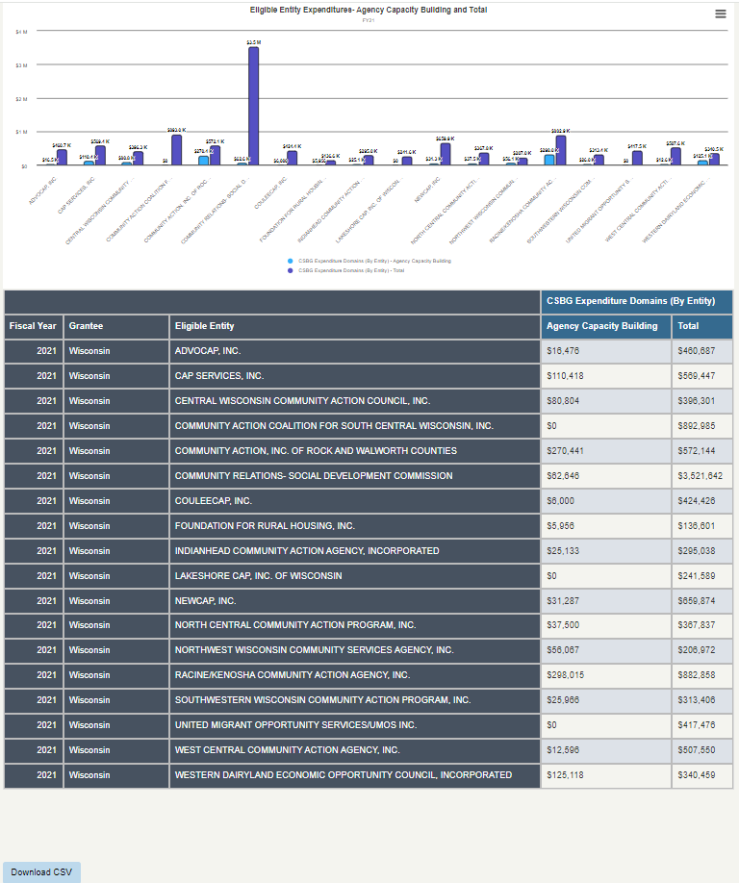

To answer Question #3, we can download the data table to Excel by clicking “Download CSV.”

By dividing spending on agency capacity building by total CSBG spending for each eligible entity in Excel, we can answer Question #3: The eligible entity that spent the highest share of their CSBG funds on agency capacity building in FY21 was Community Action, Inc. of Rock and Walworth Counties.

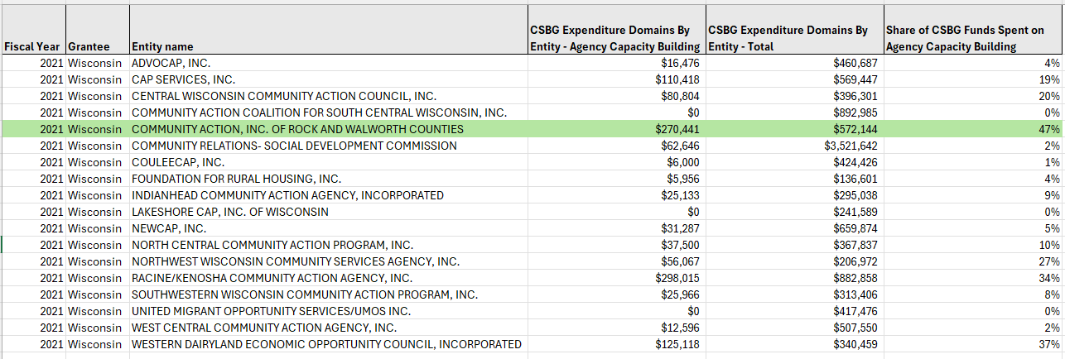

Scenario 3

